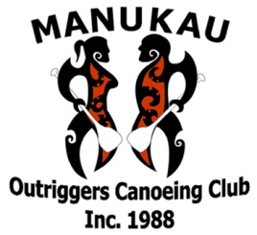
PO Box 22 025
Otahuhu

TAITAMARIKI/INTERMEDIATE REGATTA

MANUKAU OUTRIGGERS CANOEING CLUB INC

Sunday 28th March 2021

Registrations close Thursday 25th March 2021
All entries need to be registered online only (requirement for COVID tracing), and you will need to see your club rep for registrations

This is a Gold Coin Donation event for each paddler and will be collected at registration

Please ensure you complete your team waivers before registration

Event location:

Ian Shaw Park, 252A Panama Road, Mt Wellington, Auckland – parking is very limited

Event start time:

8am – 8.30am set up
9am – 9.40am Registrations & safety checks
9.40am Briefing – W6 250m & W6 500m
10am Race starts

Event outline:

W6 – waka racing Midgets/Intermediates (Waka supplied on day)

W6 – Midget 2ks & Intermediates 4ks

Safety check:

Each paddler must wear/bring own life Jacket, bailer x 2 & own paddles

x3 support boats & W6 will be within estuary while racing

